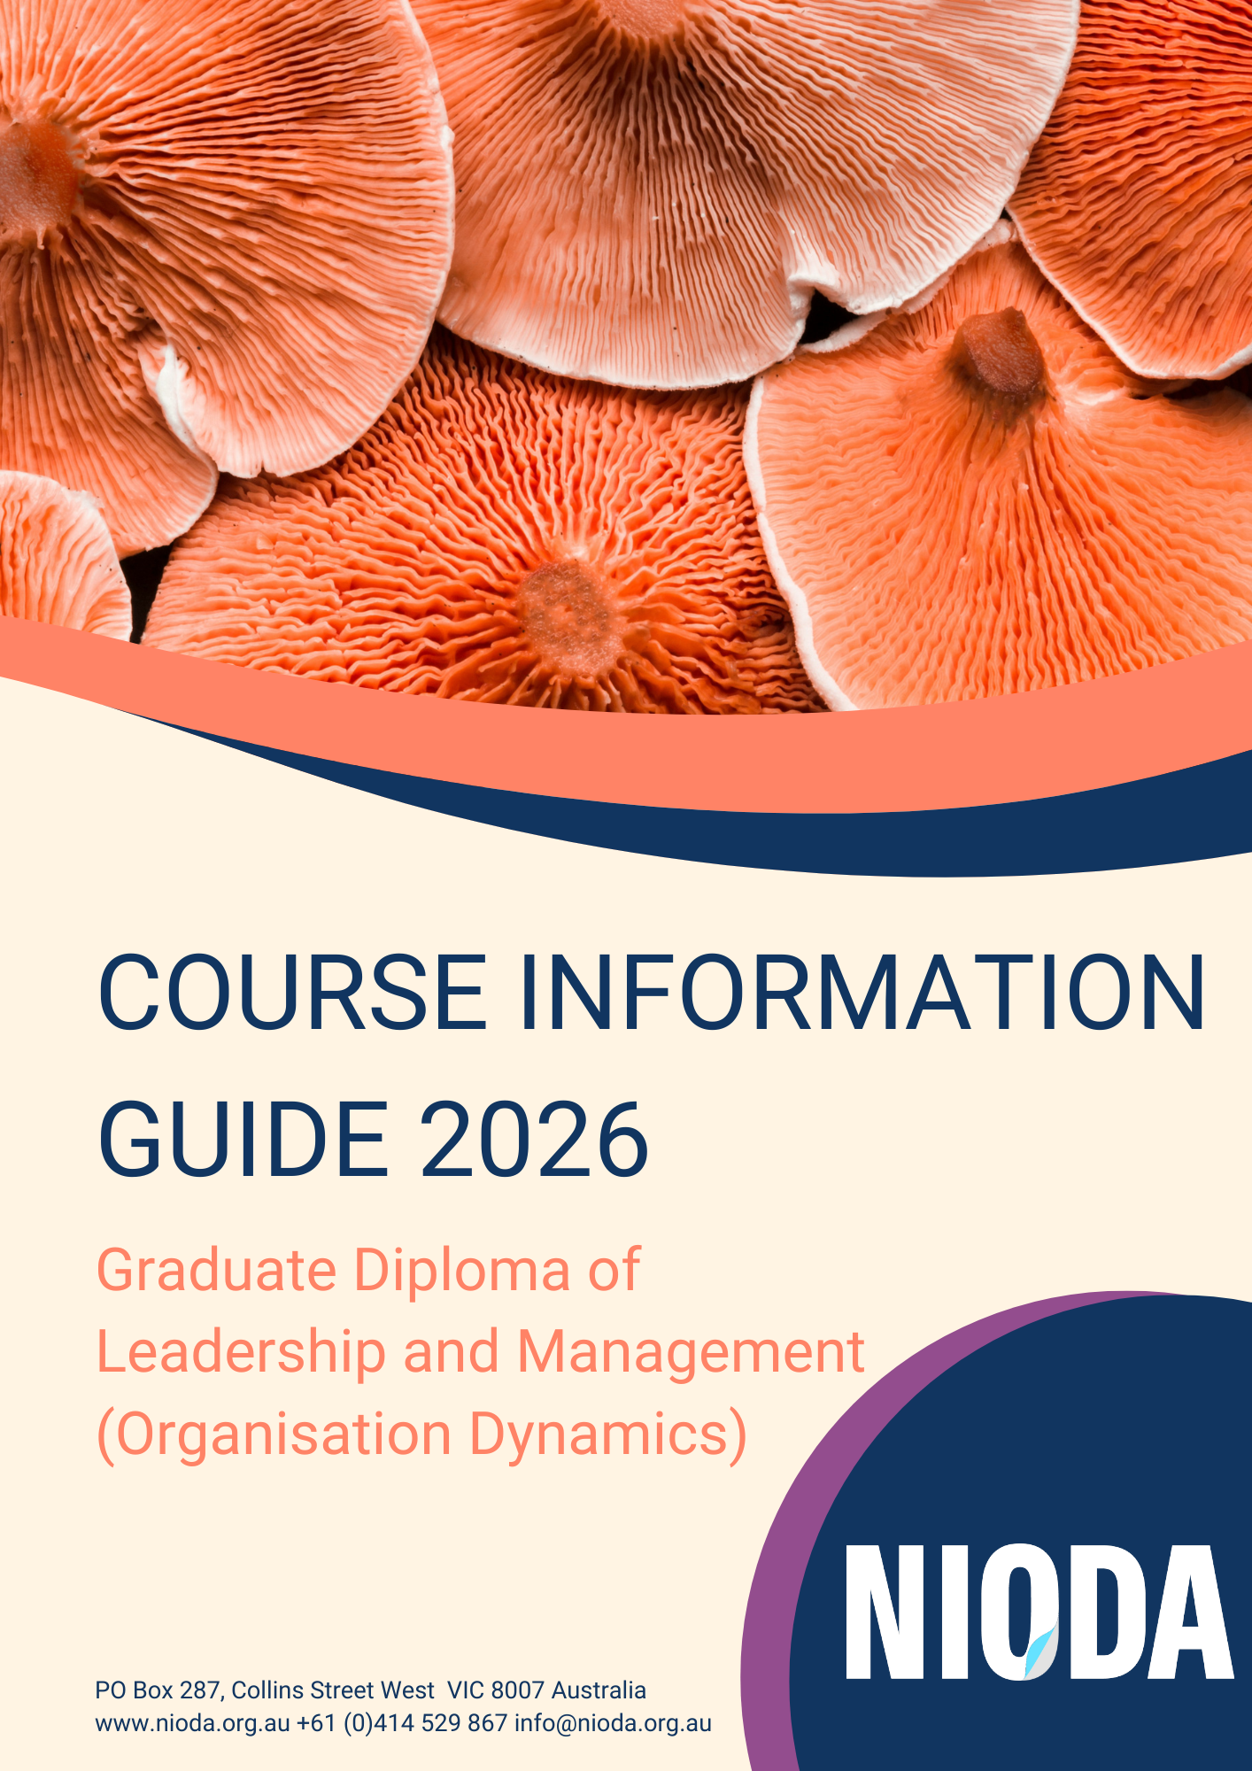

Contents

About NIODA 2
Registration and Accreditation 2
Local and Global Professional Bodies 2
Introducing the Graduate Diploma of Leadership and Management (Organisation Dynamics) 2
Distinctive Design Features 3
Course Outcomes 3
Course Structure 4
Subjects and Progression 4
Core Units 4
Subject Outlines 4
MLM1 – Organisations and Management Through the Art of Metaphor 4
MLM2 - Unconscious Processes in Groups and Systems 5
MLM3 - Through a Cultural Lens: collaborating with the ‘other’ at work 6
MLM4 - Systems Psychodynamic Consulting 6
MLM5 - Strategy in Complex Systems 7
MLM6 - Organisational Role Analysis 8
MLM7 - Managing Beyond Organisational Boundaries: Networks and Other Relations 9
MLM8 - Leadership and Authority for Role and Task 10
Course Admission Requirements 10
Enrolment 11
Recognition of Prior Learning and Credit Transfer 11
Fees 11
Withdrawal or Cancellation 11
Exit Points 11
Grievances 11
Online Services 12
Policies and forms 12
Academic and Research Integrity 12
Student Support Services 13
Staff 13
Dean 13
Master’s Course Lead 13
Academic staff 13
CEO 13
Student Services Lead 13
Further enquiries 13

About NIODA
Thinking differently, creating possibilities, changing the world of work.
The National Institute of Organisation Dynamics Australia (NIODA) has grown from long traditions and practice in systems psychodynamics in Australia for over 40 years. NIODA was established in 2010 for the purpose of providing education in systems psychodynamics and advancing the field through leading edge research and development for the improvement of organisations, community and society.
We are an international centre of excellence advancing systems psychodynamics and making an impact on the world of work.
NIODA’s values of Openness, Collaboration, Respect, Dialogue, Reflection, Creativity and Rigour shape and inform all that we do. These values are of particular importance in informing our planning and are reflected and lived in implementation.

Registration and Accreditation
NIODA is an accredited Institute of Higher Education (registration no. 14039 in 2016). NIODA’s Graduate Diploma of Leadership and Management (Organisation Dynamics) degree is accredited under the Tertiary Education Act.
NIODA’s accredited courses and graduation processes are compliant with the Australian Qualifications Framework (AQF) Levels, Criteria and Qualification Type, Learning Outcomes Descriptors and its Qualifications Issuance Policy.

Local and Global Professional Bodies
Group Relations Australia (GRA, www.grouprelations.org.au) is the professional body for systems psychodynamic practitioners in Australia, and the International Society for the Psychoanalytic Study of Organisations (ISPSO, www.ispso.org) is the international body.

Introducing the Graduate Diploma of Leadership and Management (Organisation Dynamics)
The Graduate Diploma of Leadership and Management (Organisation Dynamics) is designed for work-experienced professionals who wish to develop their capabilities through the application of systems psychodynamic concepts to organisational leadership and management. Ultimately, it is designed to support individuals to shape and to take up their work roles in ways that are more meaningful, values-based and that best serve the purpose of the organisation.
The course fosters analytic and academic skills aimed at deepening students’ understanding of the unique demands of particular work systems and enhancing their appreciation of the professional, political, cultural, emotional and ethical nuances of organisational life. It provides industry-relevant, post-graduate education grounded in rigorous conceptual development and work experience.
Students can expect a course that:
- integrates work experience with academic theory
- uses international university benchmarking to enhance course development, delivery and relevance
- provides opportunities for engagement with real-world learning in a social and global context
- facilitates connections across disciplines and contexts through an integration of psychological, sociological, anthropological and philosophical approaches to organisations.

Distinctive Design Features
The Graduate Diploma of Leadership and Management (Organisation Dynamics) is designed for learning to be problem-based within a conceptual framework for understanding organisation dynamics. It is only offered on a part-time basis to people with an appropriate level of work responsibility and experience.
The course is designed around cohorts of students learning together across time. It is a ‘temporary’ organisation within which students study the emerging classroom dynamics alongside the issues that concern them within their own organisations. Small student cohorts (fifteen or less) enter Year one and remain together as a learning group, as far as possible, across the three-year course. This cohort-based design seeks to maximise depth learning through the development of trust and familiarity with group members’ work issues. As cohorts progressively deepen their capacities to explore and think together, the course content and student experience become more meaningfully interrelated. There is increased opportunity for students to venture into creatively applying their learning in the workplace.
Assessments reflect the focus on work-integrated learning. The assignments are practical in application whilst also requiring the use of rigorous theoretical concepts.
The course is a carefully designed learning experience that is tailored to support incremental learning that builds semester by semester across the course.

Course Outcomes
On successful completion of the Graduate Diploma of Leadership and Management (Organisation Dynamics) graduates will be able to:
- analyse theory and practice spanning systems, psychodynamic and group relations disciplines to understand group and organisation effectiveness
- explore the use the self as an instrument and recognise personal experience as potential data about group dynamics
- apply the skills of thinking and writing through the creation of working hypotheses, analyses and articulation of findings
- appraise the hidden or unconscious connections and defences operating between people, tasks, structure, technologies and context that affect work group functioning and task accomplishment
- explore organisational culture and functioning using the principles of socio-technics to design interventions and improvements
- apply systems psychodynamic concepts within a considered ethical framework for managing, process consulting, problem-solving and supporting creative movement with organisations and groups.

Course Structure
The course is offered in part-time mode only. In total, completion requires four semesters of part-time involvement, or longer if undertaking one subject per semester.
Subjects are taught in live interactive online weekly classes and full day sessions, with onsite opportunities in Melbourne.

Subjects and Progression

Core Units
Year One
MLM1 Organisations and Management through the Art of Metaphor (12 credit points)
MLM2 Unconscious Processes in Groups and Systems (12 credit points)
MLM3 ‘Through a Cultural Lens’: collaborating with the ‘other’ at work (12 credit points)
MLM4 Systems Psychodynamic Consulting (12 credit points)
Year Two
MLM5 Strategy in Complex Systems (12 credit points)
MLM6 Organisational Role Analysis (12 credit points)
MLM7 Managing Beyond Organisational Boundaries: networks and other Relations (12 credit points)
MLM8 Leadership and Authority for Role and Task (12 credit points)

Subject Outlines

MLM1 – Organisations and Management Through the Art of Metaphor
Subject Content
The subject introduces a breadth of organisation and management theory and practice to support students in coming to understand their own primary ‘taken for granted’ theories of organisation and to explore alternative theories that may open up options for managing or conceptualising management.
A range of metaphors of organisation (Morgan 2006) are used as the primary vehicle for ordering and communicating organisation and management theory and practice. Each metaphor represents a distinct body of management theories that underpin particular assumptions about managing. Furthering the call of Morgan and others (Mintzberg 2011; Needham 2014) for understanding and application of multiple perspectives in management practise the study of each metaphor is supplemented with ancillary readings which critically examine the strengths, weaknesses and case application of each perspective.
This design develops an art of metaphorical analysis that combines theory and practice to assist students in working with competing models of organisations as expressed in the management literature, their own experience, and the language of the organisations with which they currently work.
Student Learning Outcomes
On successful completion of MLM1 students will be able to:
- locate system psychodynamics and its core concepts in the field of organisation and management studies as understood through metaphoric analysis;
- critique organisational and management theory, both in the relevant literature and as observed in practice, by eliciting and examining the metaphors underlying mindsets and behaviours;
- apply qualitative research methods particular to the systems psychodynamic field by working on personal and organisational metaphors in small groups and individually;
- explore organisational and management practice using metaphoric inquiry; and
- apply selected metaphors to designing and working with change in organisations.
Assessment
- A small learning group report
- Individual essay
- Learning journal

MLM2 - Unconscious Processes in Groups and Systems
Subject Content
This subject offers intensive exploration of small group dynamics through a ‘study group’ methodology. Across the semester the student group explore their own conscious and unconscious patterns of small and large group behaviour in the ‘here and now’ using group/system level analysis. This approach presents students with an in-depth opportunity to experience and analyse small group dynamics with reference to object relations and intersubjective conceptual frames.
Through these experiences, it is anticipated students increase their capacity to identify, analyse and manage workgroup dynamics; to appreciate the emotional labour of work, and to enable constructive leader-follower relations.
Student Learning Outcomes
On successful completion of MLM2 students will be able to:
- critically discuss systems psychodynamic approaches to understanding work group behaviours;
- outline object relations and intersubjective theory applicable to systems thinking;
- understand their own valency for the roles that they typically take up in groups;
- develop working hypotheses about unconscious dynamics in small and large groups, using observation, personal experience and patterns of role taking as data;
- investigate dynamics in groups and between leaders and followers that support or obstruct task performance, including identifying social defence processes in systems; and practice ways of working with uncertainty and paradox in groups.
Assessment
- Individual essay
- Small learning group essay

MLM3 - Through a Cultural Lens: collaborating with the ‘other’ at work
Subject Content
This subject aims to encourage in-depth learning about the group phenomenon of culture. This is facilitated by an ‘inside out’ understanding of the complexities of culture and enculturation. To this end students are first encouraged to explore the impact of enculturation on their own work choices and practice and then to explore and analyse the culture developed within the ‘here and now’ of the class; the intention of these activities is to translate learnings to understanding and working with organisational culture.
A working description of ‘culture’ is ‘that which has been absorbed by us (people like me) as the preferred means and ends for living and dying’. It is taken for granted that aspects of this absorption of culture will be in focus, since it is difficult to understand the cultural aspect of tensions with people who are ‘not like us’ (diversity) unless we can appreciate something of the social construction of who we, collectively, have become.
In keeping with the course’s psychodynamic emphasis, we remind ourselves at times that the boundary between ‘me’ and ‘you’/us’ and ‘them’ is often created unconsciously to defend against internal threats by attributing undesirable qualities to the ‘Other’.
Student Learning Outcomes
On successful completion of MLM3 students will be able to:
- critique selected organisation/management/human resource literature on topics related to culture, diversity and inclusion;
- critically apply the concept of culture as a psycho-social process to identify conscious and unconscious factors that create and influence culture in organisations;
- identify and articulate the impact of enculturation on their own work choices and practices;
- describe the impact of intercultural dynamics on communication and collaboration in organisations; and
- use a cultural lens to identify covert or veiled factors that affect group and organisation effectiveness and outcomes.
Assessment
- Individual essay
- Small learning group assignment
- Learning journals

MLM4 - Systems Psychodynamic Consulting
Subject Content
The purpose of this subject is to have students explore, understand and clarify varying assumptions about the technique of consulting, whether from a manager or specialist role, internal or external to the organisation, and to practise the skills of systems psychodynamic consultation.
Through its workshop design, the subject provides an intensive practical exploration of systems psychodynamic consulting by having students undertake a ‘real-life’ consultation to an organisation. Students are able to learn about systems psychodynamic consulting and to discover, through practical application, how much they have learnt from their first year of study.
In small learning groups students undertake a five-day consultation with an organisation, returning to the classroom at predetermined times to explore their experience of entry, contracting, method, client/consultant relations, working as a consultancy team and exit from the organisation. The classroom experience is also considered a ‘temporary learning organisation’ where internal dynamics are explored as potential data for what might be occurring at a deeper level in the organisation being consulted to.
Student Learning Outcomes
On successful completion of MLM4 students will be able to:
- articulate the distinction between various types of consulting practices and how they can be applied as an aspect of the manager’s role and as a specialist role
- describe the values and ethical issues for process consultants,
- manage effective entry into an organisation, determine and contract to the central question/s of the consultancy, and successfully exit the organisation;
- apply system psychodynamic methods and analysis in consulting to an organisation, identifying and managing tensions in the client/consultant relationship; and
- integrate key theories and learning from previous subjects into their understanding of applied systems psychodynamic work
Assessment
- Consulting system (team) presentation
- Individual essay
- Learning journals

MLM5 - Strategy in Complex Systems
Subject Content
This subject encourages students to critically examine the connections between the internal dynamics of organisations and the external environment their members imagine, respond to and/or create through their work. As such, the subject involves an examination of the concept of ‘strategy’ by considering it as a representation of the way links are made between the inside and the outside of a work system.
The subject challenges the common conception (in management circles) of the term ‘strategy’ as a vital descriptor; as in ‘strategic planning’, ‘strategic management’, ‘strategic mindset’, ‘strategic marketing’, ‘strategic change’, ‘strategic partnerships’ etc. Little attention is given in the literature to what the term ‘strategic’ means to organisation members and how it impacts their sense of purpose and values. What might it represent about the way they feel related to each other in their work, and related to the external ‘Other’, whether this ‘other’ is labelled the ‘environment’, the ‘competition’, the ‘market’, ‘best practice’, the ‘forces of globalisation’ etc.
Across the semester the subject explores the hypothesis that an unexamined reliance on the idea of strategic planning is a defence against the complexity and uncertainty of managing when the primary task is experienced as unclear, contested or unsustainable and when the ‘environment’ is experienced as volatile. This hypothesis can be explored through the related ideas of ‘judgement’ and ‘institution’: ideas that seem to have less and less currency in the lexicon of ‘strategic’ management. For the purpose of this subject, the strategy process is considered to be about the way in which the ‘inside’ of an organisation is connected to its ‘outside’; both in the material sense of an organisation transacting with its environment to produce outputs and in the psychic, in-the-mind, sense of people within organisations connecting their desires with the reality of work as they experience it.
Students work on a whole of semester assignment exploring an aspect of the strategic process in their own workplace with respect to ideas stimulated through class discussions and exploration of the subject readings.
Student Learning Outcomes
On successful completion of MLM5 students will be able to:
- articulate variations in the concept of strategy as explicated in contemporary management literature, including socio-technical systems theory and complexity science;
- analyse the ecology of organisations and their dynamic relationship with their environments;
- observe and critically evaluate individuals and groups in selected organisations to identify the creative and defensive dynamics in the process of strategy formulation;
- implement methods of strategic enquiry, reflective interviewing, and collaborative data analysis to understand task and sentient system dynamics that may be contributing to difficulties in identifying risk, opportunity and strategic change; and
- apply socio-technical and complexity theory to design interventions and work with change processes in organisational systems.
Assessment
- Individual essay and annotated bibliography
- Small Learning Group Assignment: group essay and class presentation
- Learning Journal

MLM6 - Organisational Role Analysis
Subject Content
Opportunities are provided in this subject to study relevant concepts about the interactions between person and system that shape work roles and task; concepts that are central to socio-technical systems theory. The subject aims to equip students, through reading, discussion and practice, with the skills to conduct Work Role Consultation as a specific method for leadership and management development and/or applied research.
Students are guided and assisted in exploring ‘role’ as a basic unit of the social structure of work organisations. They are then introduced to a methodology of role consultation and are supervised in their practice of this method for improving the management of themselves and others in work roles. Students learn to take responsibility for the management of the consultant/client relationship as they assist their clients to take up responsibility for their work role performance.
Student Learning Outcomes
On successful completion of MLM6 students will be able to:
- outline key concepts relevant to ORA and their relation to leadership, authority and innovation in organisations;
- analyse their own work role identifications and tensions using ORA tools and concepts as a means of understanding role and organisational challenges and to inform application;
- integrate a theory of role at the intersection of organisational context, system, individual role holder and deeply held values into the practice of coaching;
- demonstrate skills in collaborative analysis (with a client) using tools of role drawing and role biography to diagnose, understand and transform role and system dilemmas in organisations; and
- develop strategies for using ORA concepts and tools in other applications such as role conversation/dialogue, team building, induction and performance management.
Assessment
- Individual essay analysing the student’s own work role drawing
- An individual report on the Organisational Role Analysis (ORA)
- Learning journal

MLM7 - Managing Beyond Organisational Boundaries: Networks and Other Relations
Subject Content
This subject is an introductory study of the relations between organisations, particularly referent organisations and other forms of collaboration to solve large and complex domain level problems.
As the external environment of organisations becomes increasingly complex and problematic ‘joined-up’ solutions are required. As such this is an aspect of organisation dynamics that has become more important for managers/consultants, for employees/clients and for communities (local and global).
Across the semester students study the dynamics of identity, power, authority and boundary management in actual inter-organisational collaborations, building their intellectual and practical capacities to contribute to the effective management of inter-organisational relations.
The subject encourages students to take up more responsibility for project design – finding connections to inter-organisational relations that are sufficiently interesting and/or important for them to investigate more fully through the assignment. As part of this, students study an inter-organisational collaboration.
Student Learning Outcomes
On successful completion of MLM7, students will be able to:
- critically analyse literature pertaining to the formation, purpose and dynamics of inter-organisational relations;
- evaluate inter-organisational relations in their environmental context and the unique challenges they present;
- recognise and create spaces to work with the dynamics of managing identity, authority, power and boundaries as they occur in inter-organisational relations;
- identify and manage boundary relations and their implications for both intra and inter-organisational settings; and
- create opportunities to work with others to effectively collaborate amongst inter-organisational systems.
Assessment
- Scoping paper for Inter-organisational Enquiry
- Individual report
- Reflective essay
- Learning Journal

MLM8 - Leadership and Authority for Role and Task
Subject Content
This subject is offered as a five-day ‘Group Relations Conference’. The conference aims to provide opportunities for students to study group, inter-group and organisational dynamics through direct experience. These experiences may be thought about and conceptualised, reacted to or acted upon, accepted or even unconsciously rejected. Students have a choice about how they might work with their experiences. The conference offers an opportunity for students to learn through their own ‘reflective practice’. That is, through observing, making decisions, taking up accountability and authority, exploring new roles, reflecting, taking action and through working with others. During the conference, learnings are discussed and linked to ‘back-home’ work roles through a consultancy and reflection group method.
There are no formal lectures or seminars. Instead, students take part in developing the temporary organisation.
Student Learning Outcomes
On successful completion of MLM8 students will be able to:
- articulate the experience of group, inter-group and organisational dynamics and one’s contribution to their creation;
- identify and analyse small, medium and large group dynamics relating to organisational structure, culture, sentience and task using personal experiences as data about group, intra- and inter-organisational systems;
- integrate key theories and learnings from previous subjects to form a coherent base for applied systems psychodynamic work;
- demonstrate the capacity to continue to think amidst turbulent dynamics, identifying the impact of authority and leadership on role and task and the influence of purpose, value and meaning in human systems; and
- translate learnings from the experience of a group relations conference to their own work organisation and other work organisations through integration into their work practice.
Assessment
- Individual annotated bibliography
- Individual essay

Course Admission Requirements
Completion of a three year Bachelor degree or equivalent,
and
at least five years of relevant work experience.
Special Entry into the Graduate Diploma of Leadership and Management (Organisation Dynamics) may be granted to no more than 10% of the intake in any given year for those who have not completed a three year Bachelor degree or equivalent but who have other tertiary qualifications and relevant work experience or who have extensive relevant work experience.
Students entering this degree are required to have a minimum level of English language proficiency (details of these requirements can be found at www.nioda.org.au/policies).

Enrolment
Application forms are on the NIODA website www.nioda.org.au/academic-programs.
All successful applicants will be made a formal offer of place after which they are able to enrol online.

Recognition of Prior Learning and Credit Transfer
NIODA offers students the opportunity to apply for Recognition of Prior Learning or Credit Transfer. Enquiries about RPL or Credit Transfer need to be made at the time of the application interview. Policies and links to apply at www.nioda.org.au/policies.

Fees
In 2026 the fee is AUD $3,775 per subject (AUD $15,100 per year, if undertaking two subjects per semester). Fees must be paid in full at least two weeks prior to the commencement of the semester in which the student is enrolled. There are no incidental fees charged for the course.
FEE-HELP is available for students meeting Education Department criteria.
See the https://www.studyassist.gov.au/help-loans/fee-help for criteria.
With the exception of those accessing FEE-HELP loan assistance payment for all fees should be by direct deposit or credit card made payable to NIODA.
A student withdrawing or taking Leave of Absence after the census date of the relevant semester will be charged full fees for that semester.
Fees are subject to a 5% annual increase. Fees are published on the NIODA website by October of the prior year.

Withdrawal or Cancellation
Fees will not be refunded after the census date for that subject.
Application for ‘Leave of Absence’ must occur prior to the first class in either semester.

Exit Points
Students who withdraw from the Graduate Diploma of Leadership and Management (Organisation Dynamics) after the successful completion of the first year are entitled to graduate with a Graduate Certificate of Leadership and Management (Organisation Dynamics).

Grievances
Students are able to lodge a grievance about any aspect of their studies. In the first instance this should be in writing to the Graduate Diploma’s Course Committee. This committee has discretionary authority to determine what type of procedure should occur on receipt of a grievance. This decision is based on the type and severity of the issue. Students have further grievance appeals through the Academic Board of Governance. See Candidate and Student Grievance Policy on the NIODA website www.nioda.org.au/policies.

Online Services
The learning management system at NIODA is web based and comprises student and staff portals and private Google for Education (Google Workspace) applications.
Key features include:
- library services
- online enrolment
- institution, course and subject information
- readings
- closed online discussion forums
- video conferencing and seminars/ webinars platform
- Human Research Ethics page
All students have independent accounts with Google Workspace and the option to log into Google Workspace to access relevant private ‘intranet’ site directory (portal.nioda.org.au) and restricted Google Drive (folders).
The student portal provides:
- secure, closed online discussion forums for posting notices about events that may be of relevance for the course and for uploading papers that may be of interest to the rest of the cohort
- a platform for video conferencing and seminars/ webinars
- information on Human Research Ethics application processes and relevant forms; and allows online submission of applications and follow up.
Ordinarily, students use their own laptop and/or home computers to access the NIODA website. Wireless internet access is available and supported at the Melbourne hybrid site.
The NIODA website is accessible 24 hours a day. Students are provided with log in details that enable you to first register and then personalise your password to gain access to the student portal.
Administrative and technical support for the website is available via email to admin@nioda.org.au or accounts@nioda.com.org.au. Administrative staff respond within two working days of the initial email request.

Policies and forms
All policies and forms relevant to your studies at NIODA are available on the NIODA website www.nioda.org.au/policies.

Academic and Research Integrity
The National Institute of Organisation Dynamics Australia (NIODA) values excellence and rigour in delivery and learning that is achieved in an intellectual environment where integrity is highly valued and carefully upheld. All students and staff are required to uphold the highest standards of academic and research integrity. A range of policies addressing these requirements, including NIODA’s policy on use of generative AI, can be found on the NIODA website at www.nioda.org.au/policies.

Student Support Services
NIODA students have access to support services:
- Student Advice
- Student Counselling
- IT Support Services
- Library Support
- Student Resources Information webpage.

Staff

Dean
Professor Wendy Harding, M.Bus, PhD

Master’s Course Lead
Thomas Mitchell, MLM(OD)


Academic staff
Dr Brigid Nossal, M.Ed, PhD
Seth Thomasson, M.App.Sci (OD)
Helen McKelvie, MLM(OD)
Rhianna Perkin, MLM(OD)
Kristina Karlsson, MLM(OD)
Stefan Bramble, MLM(OD)

CEO
Sally Mussared, MLM(OD)

Student Services Lead
Belinda Cashl, BA
See www.nioda.org.au for staff profiles

Further enquiries
Thomas Mitchell thomas.mitchell@nioda.org.au
Ms Belinda Cashel belinda.cashel@nioda.org.au

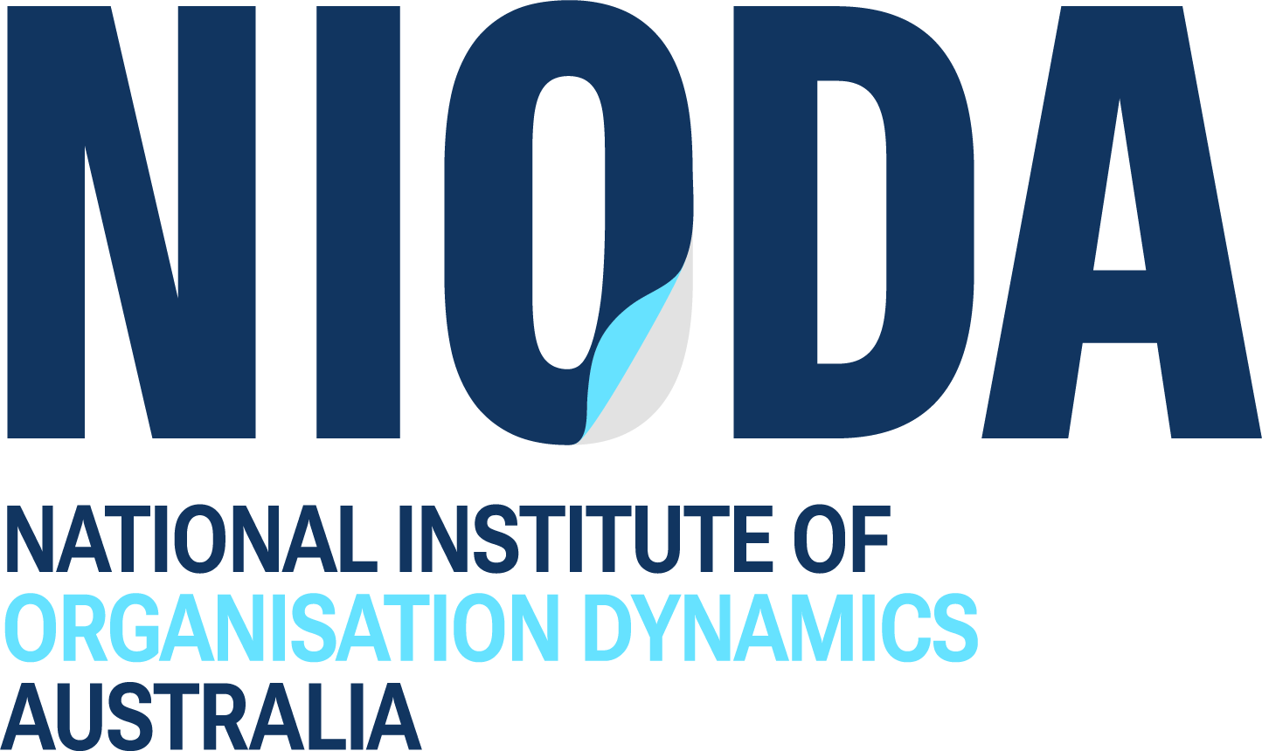

National Institute of Organisation
Dynamics Australia Ltd (NIODA)

PO Box 287, Collins Street West, Melbourne VIC Australia
www.nioda.org.au +61 (0)414 529 867 info@nioda.org.au

NIODA is a not-for-profit Company Limited by Guarantee, registered in the state of Victoria.

Institute of Higher Education no. 14039
ABN 97 897 654 659 ACN 607 032 888

